TTC
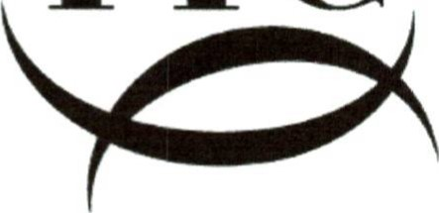
TRINITY THEATRE CLUB
October 2023
Dear Member,
AGM Invitation
The Tunbridge Wells Theatre Club Annual General Meeting will be held this year on
Wednesday 22nd November at 8:00pm at St John's Yard, 66 St John's Road, Tunbridge Wells TN4 9PE
Please be advised that Andrew Richards and Lester Young have stepped down from the committee. The remaining 8 members have indicated that they are willing to stand for re-election. This means there is a vacancy for the Secretary, Membership Secretary and there are vacancies for ordinary committee members. The maximum number for committee is 14. These committee posts are essential for the effective running of your club so please don't leave it to others and please consider if you would like to serve on the committee.
Please return the enclosed nomination paper no later than Wednesday 15th November 2023
If you wish to submit any motion for consideration then please also send the details no later than Wednesday 15th November 2023.
NB: Motions received after that date or raised from the floor at the meeting cannot be discussed.
Attached for your information is the a AGM invitation, the agenda, a committee nomination paper and last year's AGM Chairman Report.
If you cannot make the meeting, please send your apologies. We will be limited on numbers at the venue so please let us know if you are attending.
Nomination form submission, responses and any questions to: membership@trinitytheatreclub.co.uk.
Kind regards Chris Howland
Chair

membership@trinitytheatreclub.co.uk

